Three steps to get started

A task

Do the task is one of the main content of the game, both to let you into the game world, but also to gain considerable experience, money and other incentives.

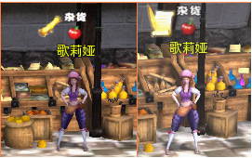

Click on the icon overhead reel has stowed kind of game NPC can access the task, click the scroll icon head has expanded like NPC can be delivered tasks.

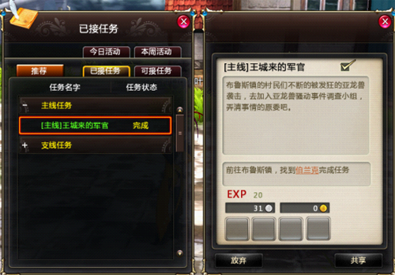

When do not know what to pick up the task, you can press the U key to open the task pane view.

Click on the underlined text can automatically find its way.

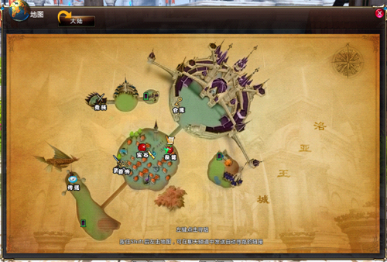

Press M to open the current map, left-click on the place to go, you can easily arrive automatically find its way.

Click on the top left corner of the current map [mainland] icon to open the world map.

Second, Personals

In the game and playing with friends is the most fun thing.

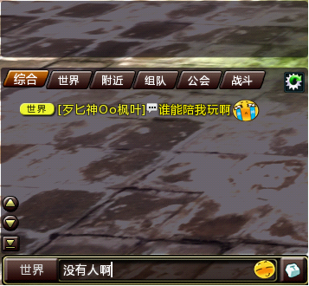

Press the Enter key, chat input box will appear, in which you can enter text, press Enter again to send a chat message. In no time chat, press Enter, you can close the chat input box.

Third, Daguai

Destroy monsters in the game is the main method protagonist ability to grow.

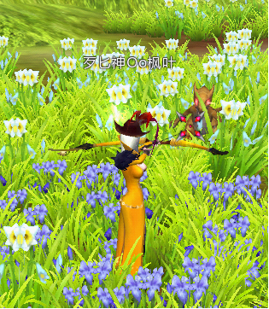

Move the monsters sight, front sight turns red when left click to attack monsters.

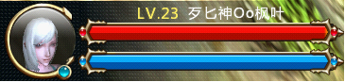

Pay attention to their own lives and magic battle.

Red for life, blue magic.

When life and low magic, when to use the appropriate pharmaceutical supplements to life.

http://img.linekong.com/lm_edt/000/002/031n32408.png

Left for the dosing of life, the right to add the magic of medicine.

[Right] mouse click to use.

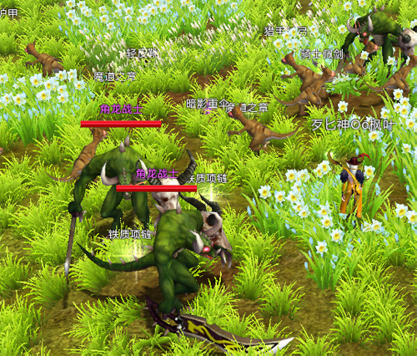

After Daguai loot, you can press the Alt key to display / hide the names of objects falling on the ground.

Left-click on the item or use the keyboard shortcut [F] can pick up items.

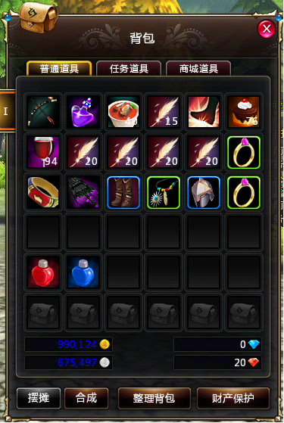

Pick up the items directly into the parcel.

Press the B button to open the package, right-click on the item to use, if you right-click the equipment is worn to the body.

Press the P key to open the role information panel, you can see just worn equipment.

When the newly acquired equipment is higher than the current figure scoring equipment, you can press the "V" key to quickly dress up according to the system prompt.